User Guide

jWebSocket
API for smart card management
V 1.0

Version Control
Date | Version | Description | Author
04/03/2012 | 1.0 | Document Creation | Marta Rodríguez Freire

1. Characteristics of the solution
The API for the management of smart cards in web applications developed with jWebSocket framework allows the development of web applications in real time with the benefits of smart cards.
The traditional way to interact with smart cards is through layers or software libraries, technically known as middleware, which normally run on the client and they function as intermediaries between different applications and card readers. The card management using middleware running on the client carries considerable risks. Some of the disadvantages it brings is the case of software updates and adding new functionality to these libraries, should be distributed to all customers in a given system or post on a website for downloading via the network. This, besides being uncomfortable for the client, means that users seeking to interact with their cards have certain knowledge to make updates and possess a number of permits in the management of computer resources to install them.
The API for the management of smart cards in web applications developed with jWebSocket framework provides the ability to manage from the server middleware, which brings benefits as: process solution installation, flexibility in updating the functions of middleware and interoperability with multiple smart cards, server centralization of all functions required and simplifying the deployment of services. Allows the communication was not always set to a user request, but that is proactive, that the server can communicate with them without a preceding action. This is accomplished by use of the framework jWebSocket, a new technology aimed at developing web applications based on WebSockets.
Today there are solutions that manage the middleware on the server side, but do not work with WebSocket protocol that provides high levels of speed, scalability and real time.
The scalability of the server’s connections supported by jWebSocket allows high user concurrency. Stress tests performed to a server as a result jWebSocket shed 10 000 concurrent connections without affecting the response time of the application. This element ensures not only perform real-time process but to ensure a high number of users using the same service at the same instant of time.
2. Mean features
The API for the management of smart cards in web applications developed with the framework jWebSocket provides the following functionality:
- Get available readers connected to the client station.
- Establish communication with the card readers.
- Notify the connection state with the card.
- Control APDU command transmission between the server and the Web client.
- Execute operations of a middleware on the server.
This solution can be used in dissimilar areas of society; the trend now is to use smart cards for its shape, size, ease of management and access control mechanism. These make the personal and business data are accessible to appropriate users, offering portability, security and reliability.
There are many scenarios in which smart cards are used at present, among them E-Commerce can mention the use of electronic purses. These extend the use of the cards to actions as simple as pay TV, mobile telephony, public transportation, parking meters, vending machines or other markets. The cards are also used in Access Control, to allow or prevent the physical passage from one person to an area. You can also make use of them in the field of Health for patient identification and monitoring of clinical history data, as information on chronic diseases or allergic personnel inside the card.

3. Problems to be solved
Problem | Contributions of the solution
Management middleware on the client side. | The API allows managing from the middleware’s server, providing flexibility in updating the functions of the middleware, interoperability with multiple smart cards, centralization on the server all the features required and the bidirectional communication between the client and the server.
The smart card management for web applications is not done in real time. | The API allows through WebSocket protocol, establish a bidirectional communication and full-duplex, reaching real time with high levels of scalability.
4. Glossary of Terms
Smart Card: is a plastic card the size of a credit card, which contains integrated circuits that allow the execution of some programmed logic. These cards have volatile and nonvolatile memory which together with a microprocessor and operating system, allows to store, encrypt and edit information. Also supports the use of multiple applications on a single card, reprogram and resistant construction to use.
Applet: are the programs that execute in the scope from the smart card, and usually exist throughout the life of the smart card.
APDU Command (Application Protocol Data Unit): APDU commands are defined as the form that the smart card exchange data package. They may contain a command message or a reply message.
Real-Time on the Web: The real time on the Web is defined as a set of technologies and practices that allow users to receive information as soon as published by their authors, rather than checking a source of regular updates.
WebSocket: is a technology that provides a bidirectional communication channel and full-duplex over a single socket TCP (Transmission Control Protocol), addresses the limitations of the HTTP protocol by establishing a full-duplex communication (TCP) between the client and server, replacing the half-duplex communication (HTTP).
Full-Duplex: Quality of the elements that allow the input and output simultaneously.
Half-Duplex: It means that the method or protocol for transmission of information is bidirectional but not simultaneously.
Socket: A method for communication between a client program and a server program on a network.
JWebSocket framework: is a new technology aimed at developing WebSockets based applications that provide high levels of speed, scalability, security and real-time work.
5. Model of the solution
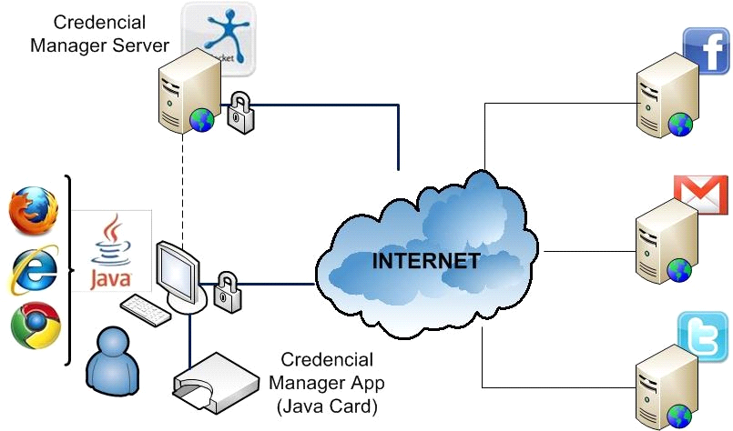

The client to authenticate using a smart card on the web, you must access a browser that supports WebSocket protocol and have Java installed on the client station so you can run the applet, element that is digitally signed so that the user may rely on its origin. The client proceeds to insert the smart card into the reader, establishing a communication between the card reader and the applet running in the browser and sends the request to the middleware in the jWebSocket server. The middleware sends a command APDU with the instructions to the card and waits for the response APDU. The card processes the command and sends the APDU response to the middleware. The credentials are obtained from the card without leaving them exposed. The client proceeds to authenticate sending credentials to the application servers where you want to log.

7. Requirements for use
To use the API to manage smart cards in web applications developed with the framework jWebSocket must have the following characteristics in the work environment:
- OpenJDK 1.7 or higher installed to run the applet in the client browser.
- Card reader to accomplish with the standard PC/SC
You must have the packages containing the client and server jWebSocket contained in version 1.0 from the URL: http://jwebsocket.org/download/.

8. Solution roles
System User: Is able to develop web applications in real time with the API for the management of smart cards in web applications developed with the framework jWebSocket.

9. System operation
Initial View: Once the client to access the application via the browser, will get a window asking you to agree to run the applet in your browser

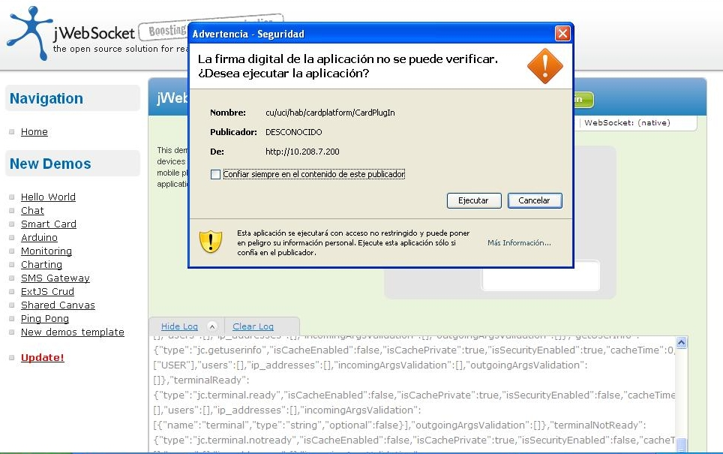

Main view of the application: The user must insert the smart card into the reader, which will extract the user's credentials.
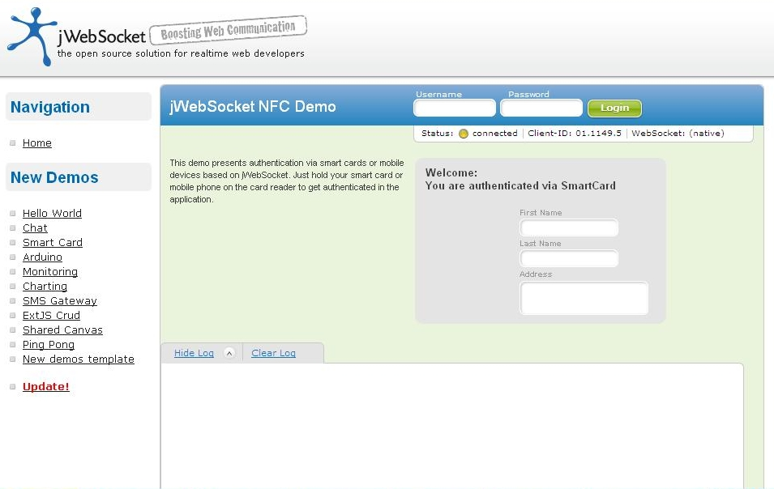

View Authenticated User: After obtaining the credentials, authenticates the user in the application and displays the customer data.

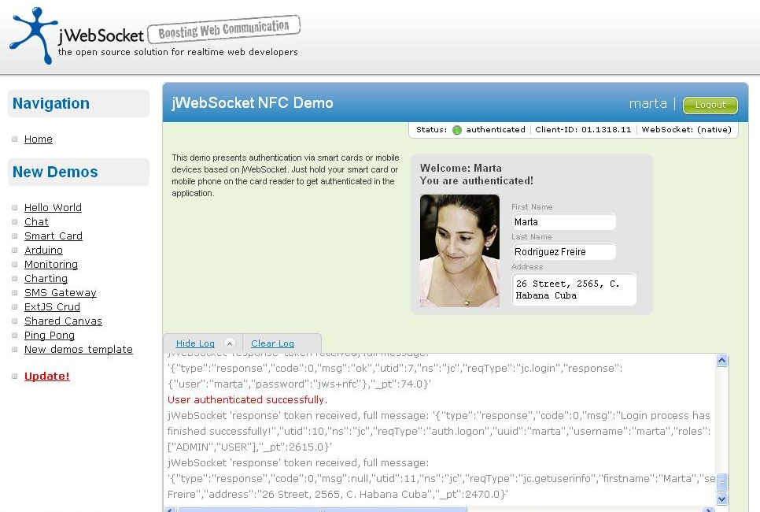

9. Solution configurations
Don't require specifics configurations

10. Solutions rules
R1: If the user don´t have the java virtual machine installed on the client machine, cannot run the applet, so you can´t communicate with readers connected to the client station and continues with the normal flow. Solution: The client must have the java virtual machine to run the applet, which will communicate with readers that are connected to the client station.

R2: If the client don't have insert the smart card into the card reader and try to perform some functionality to it, is issue an error message and does not continue with the normal flow. Solution: The client must have a smart card inserted in the card reader, to establish communication between the application running in the browser and the card reader, allowing you to run the different features.

